**Course ___Methods_Test 3_ Year __12_______**

Student name: ________________ Teacher name: ________________

Date:

**Task type: Response**

**Time allowed for this task: _____45______ mins**

**Number of questions: _____9______**

**Materials required:** Calculator with CAS capability (to be provided by the student)

Standard items: Pens (blue/black preferred), pencils (including coloured), sharpener, correction fluid/tape, eraser, ruler, highlighters

Special items: Drawing instruments, templates, notes on one unfolded sheet of   
A4 paper, and up to three calculators approved for use in the WACE examinations

**Marks available: __46____ marks**

**Task weighting: __10__%**

**Formula sheet provided: Yes**

**Note: All part questions worth more than 2 marks require working to obtain full marks.**

Q1 (3.1.6) (3 & 3 = 6 marks)

Determine the exact gradient of each of the following at the given point. Show all working.

1.  at the point 

|  |
| --- |
| **Solution** |
|  |
| **Specific behaviours** |
| 🗸 diff  🗸 subs x value  🗸 obtains derivative |

1.  at the point 

|  |
| --- |
| **Solution** |
|  |
| **Specific behaviours** |
| 🗸 diff  🗸 subs x value  🗸 obtains derivative |

Q2 (3.1.6) (4 marks)

Determine the exact area shaded in the diagram below without the use of a classpad.

|  |
| --- |
| **Solution** |
|  |
| **Specific behaviours** |
| 🗸 sets up integral  🗸 uses correct limits  🗸 shows antiderivatives  🗸 determines area |

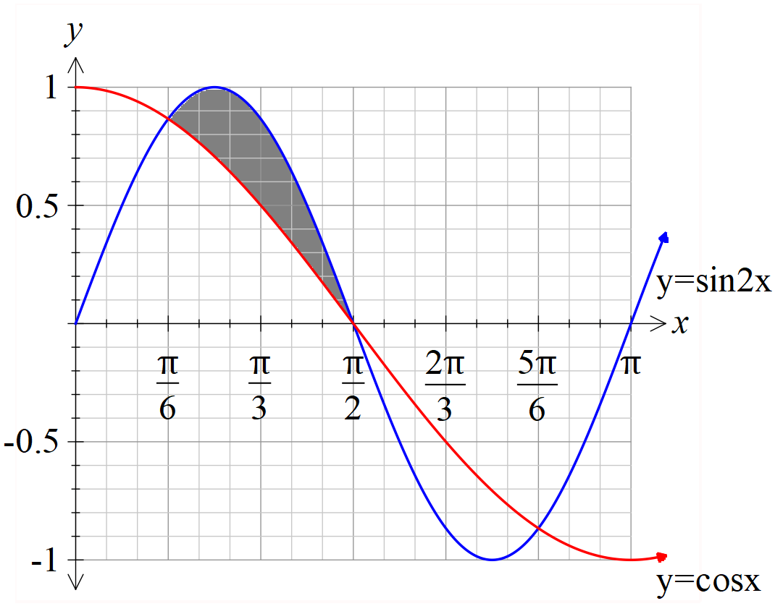

Q3 (3.1.6/3.1.10) (3 & 3 = 6 marks)

Consider the triangle drawn below with angle  radians and fixed length sides 5 & 3 cm. Let  represent the area of the triangle in .

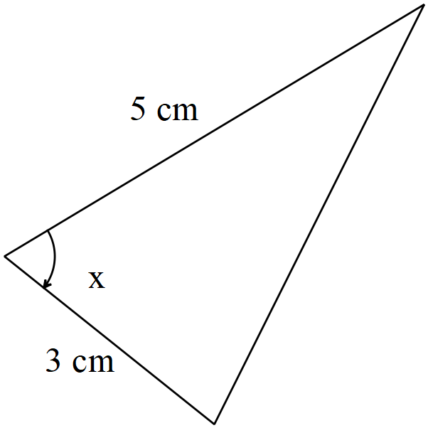

1. Determine  when .

|  |
| --- |
| **Solution** |
|  |
| **Specific behaviours** |
| 🗸 uses area formula  🗸 states derivative  🗸 subs to find exact value or approx |

1. Using the increments formula, determine the approximate change in the area when the angle changes from  to  radians.

|  |
| --- |
| **Solution** |
|  |
| **Specific behaviours** |
| 🗸 uses increments formula  🗸 subs correct values  🗸 determines approx. change |

Q4 (3.3.1) (4 marks)

The expected value of the discrete probability distribution, given below, is . Determine the values of the constants  and the variance of  to 3 decimal places.

|  |  |  |  |  |  |
| --- | --- | --- | --- | --- | --- |
|  | 1 | 2 | 3 | 4 | 5 |
|  | 0.1 | P | 0.1 | q | 0.3 |

|  |
| --- |
| **Solution** |
| Variance =1.655 |
| **Specific behaviours** |
| 🗸states one equation with p & q  🗸 states second equation with p&q  🗸 solves for p&q  🗸 states variance to 3 dp |

Q5 (3.3.13) (3 marks)

A binomial distribution has a mean of 6 and a standard deviation pf 1.9. Determine the values of , the number of trials and the probability of a success.

|  |
| --- |
| **Solution** |
|  |
| n = 15 & p=0.4 |
| **Specific behaviours** |
| 🗸 states two equations for n and p  🗸 solves approx. values  🗸 rounds n to an integer |

Q6 (3.3.7) (4 marks)

A teacher needs to scale the results of her class by first multiplying be a constant and then adding a second constant. The original mean was 72 with a standard deviation of 21, the teacher needs the scaled results to have a mean of 60 and a standard deviation of 15. Determine the values of .

|  |
| --- |
| **Solution** |
|  |
| **Specific behaviours** |
| 🗸 states one equation with constant  🗸 states two equations with constants  🗸 solves for one constant  🗸 solves for second constant |

Q7 (4.1.11) (3 & 3 = 6 marks)

The displacement of a car moving in straight line is given by  km at  hours, where .

The following questions require full working and answers only given by the classpad will not receive full marks.

1. Determine the velocity at  hours.

|  |
| --- |
| **Solution** |
|  |
| **Specific behaviours** |
| 🗸 uses product rule  🗸 diff log term  🗸 obtains speed |

1. Determine the time that the acceleration will be 0.2 .

|  |
| --- |
| **Solution** |
|  |
| **Specific behaviours** |
| 🗸 shows how to diff velocity  🗸 sets up equation  🗸 solves for t |

Q8 (4.1.6) (3 & 3 = 6 marks)

Consider the function .

1. Sketch the function on the axes below showing all major features.

|  |
| --- |
| **Solution** |
|  |
| **Specific behaviours** |
| 🗸 asymptote  🗸 shape  🗸 y less than 6 at x=10 |

1. In terms of the constants , determine the x intercept of the function .

|  |
| --- |
| **Solution** |
|  |
| **Specific behaviours** |
| 🗸 replaces x with x+2p  🗸 rearranges to an exponential equation  🗸 obtains expression for x |

Q9 (4.1.11/3.2.16) (3 & 4 = 7 marks)

This question must be answered without the use of a classpad to receive full marks.

1.  (Simplify)

|  |
| --- |
| **Solution** |
|  |
| **Specific behaviours** |
| 🗸 uses product rule  🗸 diff log term  🗸 obtains simplified expression |

1. Use the result from (a) above to determine in exact simplified form.

|  |
| --- |
| **Solution** |
|  |
| **Specific behaviours** |
| 🗸 uses linearity principle (first line)  🗸 uses fundamental theorem  🗸 obtains antiderivative and subs correct limits  🗸 gives simplified exact log expression |